Northern Ireland Does the Daily Mile Santa Run!
School briefing document
Santa run due to take place on Friday 1st December 2023 anytime between 9am and 3pm.
Thank you for registering to take part, along with other schools & early year’s settings around the country, in our nation-wide, mass participation event on Friday 1st December 2023. Within this document, you will find everything you need to make it an easy, fun and enjoyable day for everyone. We can’t wait to see your pictures online!
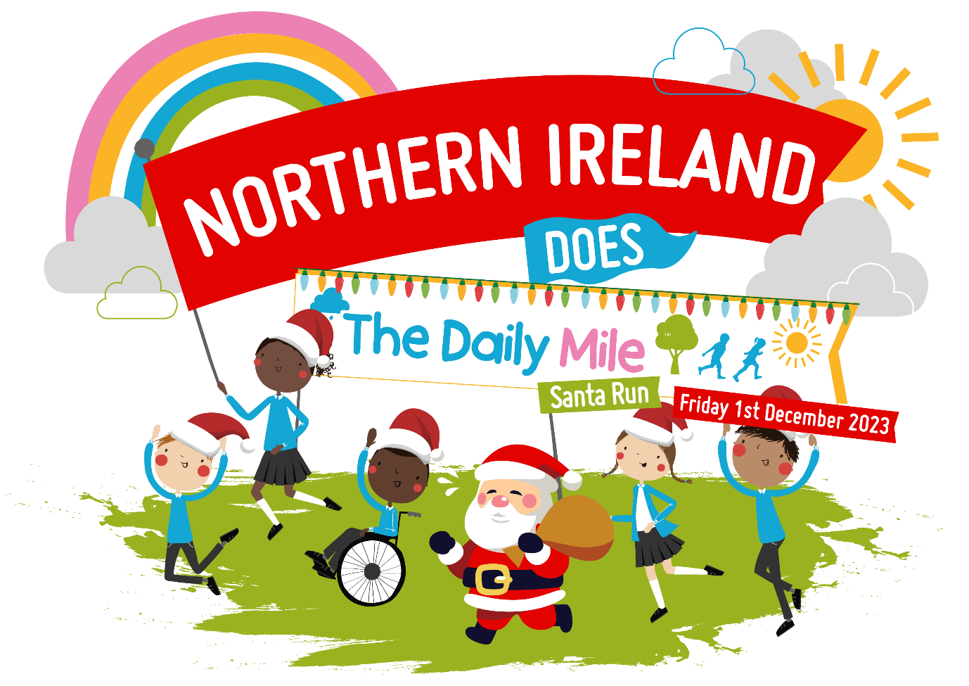

The Daily Mile™ is a simple and free initiative which gets children out of the classroom for 15 minutes every day, to walk, run, jog or wheel at your own pace. Whilst making them fitter, healthier and able to concentrate in the classroom, it has huge social and emotional benefits too.
We want as many schools & early years settings as possible around Northern Ireland, to get moving on the same day, to celebrate the positive benefits that daily activity can have on our mental health.
We bring you this event in celebration with Daily Mile Network Northern Ireland and Daily Mile Foundation.
How It Works
Northern Ireland Does the Daily Mile Santa Run is designed to be as easy as possible for your setting.
Here are our 5-steps-to-success:
1. Simply download and print the fun resources for your students from the online Hub page, (the link will be in the response email) and put up your poster in your school for everyone to see.
2. Get creative! Decorate and fill-out your Christmassy themed Back Signs* for students to wear on the day. We want to know why you do your Daily Mile – send us some photos, and we can give your setting a shout out.
3. Simply head outside and jog, walk, run or wheel on Friday 1st December 2023 to participate in your Daily Mile Santa Run at any time that suits, between 9 am – 3pm.
4. Take a photo of your setting doing your Daily Mile Santa Run, and tag us on social media or send us your photos through email below, so we can see and celebrate your activity.
5. Be awarded your special Santa Run certificate, signed by founder Elaine Wyllie, as a big thank you and to acknowledge your pledge towards better children’s mental health!
The Back Signs*
Please find more information within the ‘Back Signs: How-To’ document, within the online Hub.
Marketing:
We have some free marketing resources to promote the event to your students, parents, carers, governors, and online communities.
- Save the date flyer
- A Santa run graphic
- 3 back signs for your photos & back signs brief
- Daily Mile class tracker sheet to keep you going throughout December & January
- Daily Mile booklet – how to set up your own Daily Mile
- Santa run certificate

Please be sure to include the following information on any social media activity:
Campaign hashtags:
• #thedailymile #thedailymile_ni #dailymilesanatarun #teamSHSCT
Tagged Accounts:
• Tag us through: @_thedailymile @thedailymile_ni OR Southern Health & Social Care Trust: @SouthernHSCT
We encourage you to share your involvement, but please make sure that you have photo consent for any photos / images you post in relation to this event. The event organisers cannot accept any responsibility for this.
If you need any further information, please do not hesitate to contact Clare Drummy physical.activity@southerntrust.hscni.net
For more information about The Daily Mile, please visit: https://thedailymile.co.uk/
Register your setting with The Daily Mile Foundation if you haven’t already done so through the link - https://thedailymile.co.uk/school-signup/

