Northern Ireland Does the Daily Mile
9am-3pm on Friday 28th May 2021
School briefing document
Thank you for registering to take part, along with other primary schools around the country, in our nation-wide, mass participation event on Friday 28th May 2021. Within this document, you will find everything you need to make it an easy, fun and enjoyable day for everyone. We can’t wait to see your pictures online!
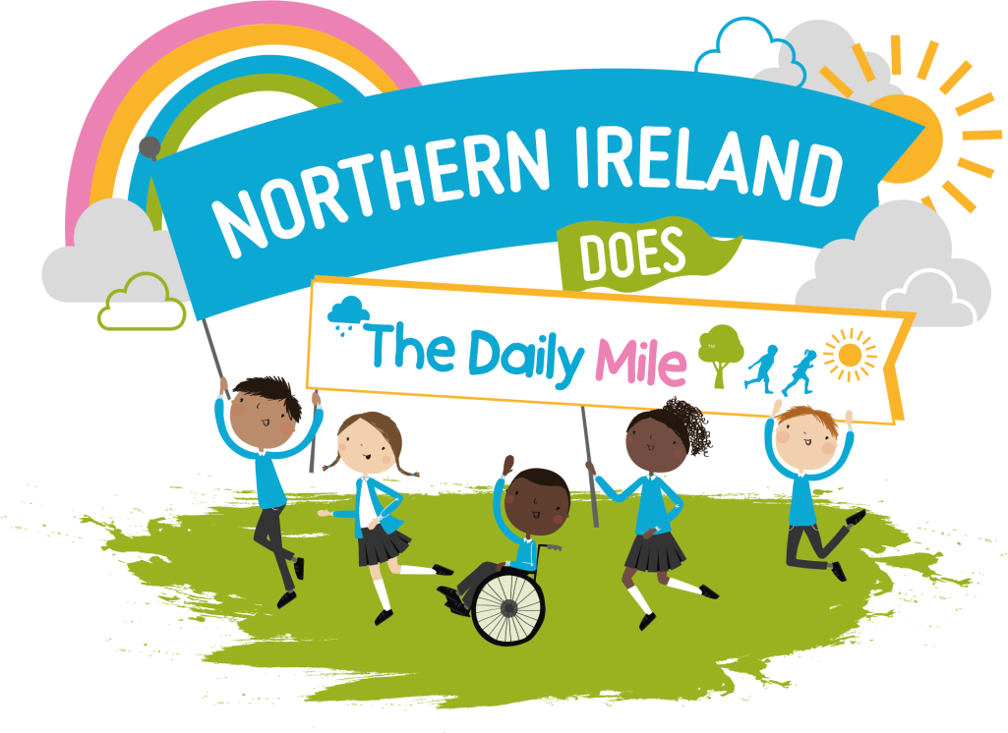

The Daily Mile™ is a simple and free initiative which gets children out of the classroom for 15 minutes every day, to run or jog at their own pace. Whilst making them fitter, healthier and more able to concentrate in the classroom, it has huge social and emotional benefits too.
We want as many primary schools as possible around Northern Ireland, to get moving on the same day, to celebrate the positive benefits that daily activity can have on our mental health.
In light of the events in the past year, children’s mental health, and its relation to physical activity, is
more important than ever. We bring you this event in celebration with Daily Foundation, as while we can’t be together in person just yet, can we get children in NI moving?
How It Works
Northern Ireland Does The Daily Mile is designed to be as easy as possible for schools!
Here are our 5-steps-to-success:
1. Simply download and print the fun resources for your students from the online Hub page, and
put up your poster in your school for everyone to see.
2. Get creative! Decorate and fill-out your Back Signs* for students to wear on the day. We want
to see why you do your Daily Mile – send us some photos, and we can give your school a shoutout.
3. Simply head outside and do you Daily Mile at any time that suits your school, on Friday 28th May,
between 9 am – 3pm.
4. Take a photo of your school doing your Daily Mile, and tag us on social media so we can see and
celebrate your activity.
5. Be awarded your special certificate, signed by founder Elaine Wyllie, as a big thank you and to
acknowledge your pledge towards better children’s mental health!
The Back Signs*
Please find more information within the ‘Back Signs: How-To’ document, within the online Hub.
Marketing:
The Northern Ireland Does The Daily Mile online Hub (that only schools who sign-up to the event can access)contains a whole raft of free marketing resources to promote the event to your students, parents and carers, governors, and online communities.
- NI Does the Daily Mile posters
- A printable window-sticker
- Back signs for use on the day with instruction guide
- Save the date flyer
Please be sure to include the following information on any social media activity:
Campaign hashtags:
• Northern Ireland Does the #DailyMile
Tagged Accounts:
• Tag The Daily Mile Foundation: @_thedailymile
We encourage you to share your involvement, but please make sure that you have photo consent for any photos / images you post in relation to this event. The event organisers cannot accept any responsibility for this.
If you need any further information, please do not hesitate to contact Clare Drummy physical.activity@southerntrust.hscni.net
Or, for more information about The Daily Mile, please visit: https://thedailymile.co.uk/

